## Introduction to Sets

A *set* is an unordered collection of elements without duplicate entries.  
When printed, iterated or converted into a sequence, its elements will appear in an arbitrary order.

**Example**

>>> print set()

set([])

>>> print set('HackerRank')

set(['a', 'c', 'e', 'H', 'k', 'n', 'r', 'R'])

>>> print set([1,2,1,2,3,4,5,6,0,9,12,22,3])

set([0, 1, 2, 3, 4, 5, 6, 9, 12, 22])

>>> print set((1,2,3,4,5,5))

set([1, 2, 3, 4, 5])

>>> print set(set(['H','a','c','k','e','r','r','a','n','k']))

set(['a', 'c', 'r', 'e', 'H', 'k', 'n'])

>>> print set({'Hacker' : 'DOSHI', 'Rank' : 616 })

set(['Hacker', 'Rank'])

>>> print set(enumerate(['H','a','c','k','e','r','r','a','n','k']))

set([(6, 'r'), (7, 'a'), (3, 'k'), (4, 'e'), (5, 'r'), (9, 'k'), (2, 'c'), (0, 'H'), (1, 'a'), (8, 'n')])

Basically, sets are used for membership testing and eliminating duplicate entries.  
  
**Task**

Now, let's use our knowledge of sets and help Mickey.

Ms. Gabriel Williams is a botany professor at District College. One day, she asked her student Mickey to compute the average of all the plants with distinct heights in her greenhouse.

Formula used:

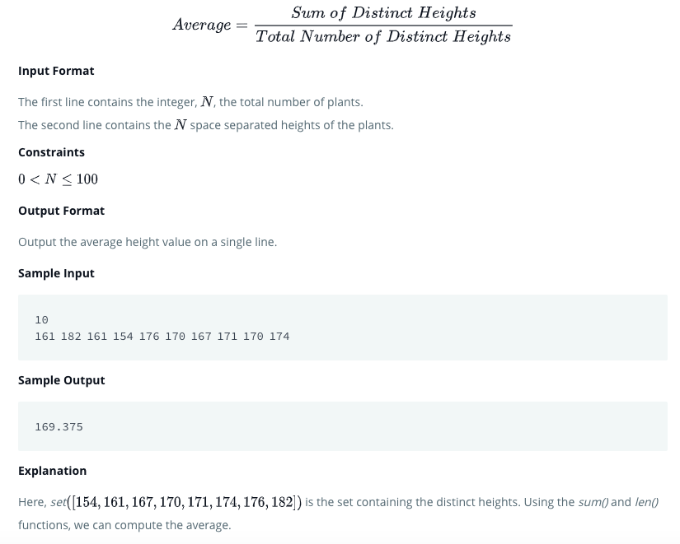

## Solution

def average(array):

    # your code goes here

    return sum(set(arr))/len(set(arr))

if __name__ == '__main__':

    n = int(input())

    arr = list(map(int, input().split()))

    result = average(arr)

    print(result)